Cotton, Slavery, and The Old South p. 292-313
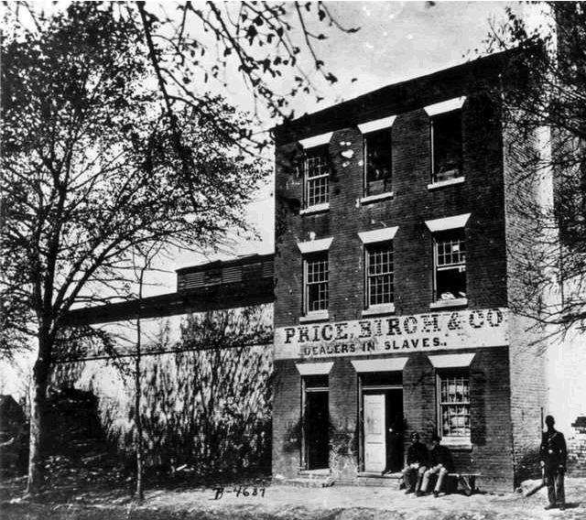1830s Auction House
CHAPTER SUMMARY
The North and South differed in many ways, but none proved more significant than the South's staple crop economy and the labor force that worked it. Cotton (and in some areas tobacco, rice, and sugar) created a system of business and commerce that made Dixie different from the rest of the nation, and the most obvious difference was the region's reliance on slavery. More than an economic system, slavery was a critical, creative force in a social order that included planters, their ladies, plain folk (men and women), and, of course, the slaves themselves. The result was a complex society that has often been romanticized and frequently misunderstood. Bound together by race and by a firm belief in a patriarchal, hierarchical system, whites of different classes and genders shared many of the same beliefs and wanted many of the same things. At the same time, there were significant differences among members of the white community, differences which were not always apparent to the casual observer. African Americans, also united by race and in most cases by slavery, found a variety of ways to maintain their dignity and, in so doing, managed to create an enduring cultural system that transcended their condition and enabled them to endure the hardships they faced.
Brinkley, Alan (2007). American history: A survey. New York, New York: McGraw Hill.
THEMES
• American Diversity: Race is the central fact of American slavery. Social and legal constructs were necessary to separate and define racial groups maintaining slavery in America.
• Culture: To cope with the harsh burdens of slavery, blacks supported a culture that assimilated their African, Caribbean, and American heritages. These traditions continue today in song, religion, family, and language, but have remained largely out of the cultural mainstream until recently.
• Economic Transformations: The growing differentiation between the Northern industrial and Southern agricultural economies is more sharply delineated in this period. As the Southern economy grew with cotton at its core, it also became more dependent on outside economic forces. Southerners recognized this, and came to fear its consequences.
• Environment: The migration into the Southwest cotton kingdom gives a clear view of a movement that occurs throughout United States history: westward movement. Wasteful agricultural techniques exhausted the soil, and Americans abandoned that land and sought new lands to the west.
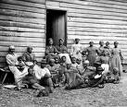
• Slavery and Its Legacies in North America: This theme is central. An important element is recognizing the two viewpoints represented in slave accounts. While whites observed laziness and incompetence in slave work, slaves often did this deliberately as a form of resistance.

Digital History Overview
The Pre-Civil War South
In the decades before the Civil War, northern and southern development followed increasingly different paths. By 1860, the North contained 50 percent more people than the South. It was more urbanized and attracted many more European immigrants. The northern economy was more diversified into agricultural, commercial, manufacturing, financial, and transportation sectors. In contrast, the South had smaller and fewer cities and a third of its population lived in slavery. In the South, slavery impeded the development of industry and cities and discouraged technological innovation. Nevertheless, the South was wealthy and its economy was rapidly growing. The southern economy largely financed the Industrial Revolution in the United States, and stimulated the development of industries in the North to service southern agriculture.
George, J. & Brown, J. (2007). AP achiever: Advanced placement american history exam preparation guide. New York, New York: McGraw Hill.
Lecture Outlines
The Peculiar Institution 1
The Peculiar Institution
Biography of America
Slavery (series 9)
While the North develops an industrial economy and culture, the South develops a slave culture and economy, and the great rift between the regions becomes unbreachable. Professor Masur looks at the human side of the history of the mid-1800s by sketching a portrait of the lives of slave and master.
Student Assignments
Ch.11-12 Primary Source
Web Links
Student Learning Center Chapter 11
Multimedia Presentations
King Cotton

