America's Economic Revolution p. 258-291
CHAPTER SUMMARY
After the War of 1812, a combination of rapid population growth, the expansion of communication and transportation systems, and the development of an agricultural system sufficient to feed an urban population gave rise to the American industrial revolution. The two sections of the nation most affected by these changes were the Northeast and the Northwest, which were drawn closer together as a result. Canals, railroads, and the telegraph made it easier to move goods and information. Business grew as corporations began to shape the world of trade and commerce. Technological innovations helped expand industries as the factory system began to replace the artisan tradition. In the Northwest, agriculture expanded to meet the increasing demand for farm products. All of these developments had profound implications for American men and women, both in the ways that they worked and in their family lives.
Brinkley, Alan (2007). American history: A survey. New York, New York: McGraw Hill.
Worker Worlds in Antebellum America
1808 Congress outlaws the importation of slaves.
1816 Eli Terry introduces his shelf clock.
1831 Nat Turner’s Rebellion in southern Virginia.
1837 Procter and Gamble founded in Cincinnati, Ohio.
1852 Congress passes steamboat safety law.
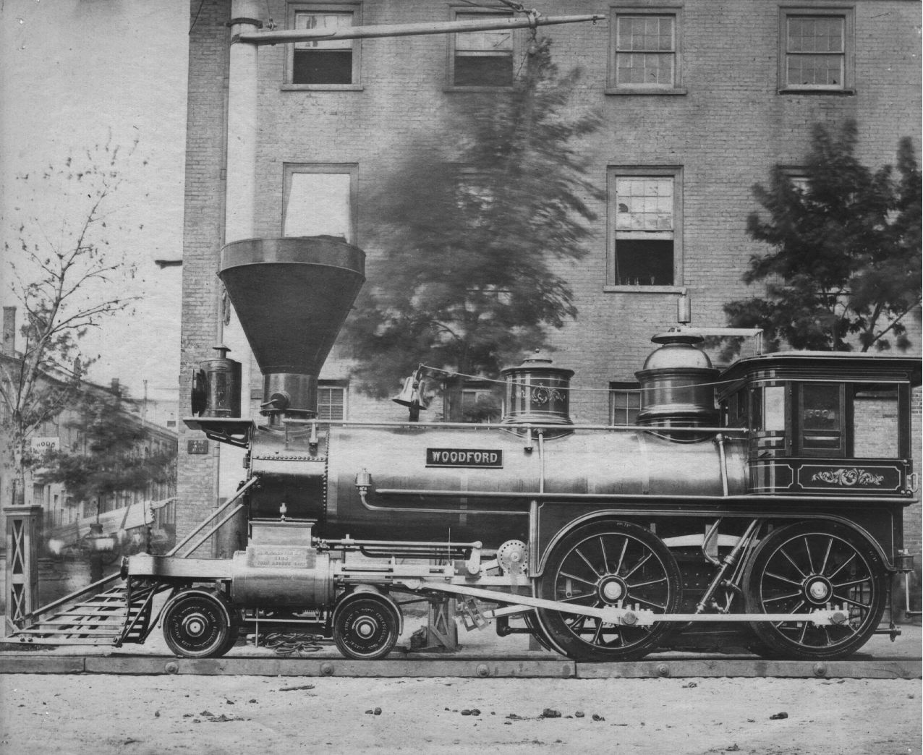
THEMES
• American Diversity: This chapter raises the issue of European immigration as an unwanted component of American society. After nearly two centuries of trying to attract immigrants to America, the influx of Irish Catholics in the 1840s stirred popular resentment and political movements with goals of keeping Irish Catholics and other immigrants as a distinct underclass in American society.
• Demographic Changes: Lower mortality rates and immigration made the period before the Civil War one of rapid population growth. The geographical center of the population was shifting westward also. One great irony of American population shifts is that as more western lands were settled, the country as a whole became more urban. Cities grew relatively faster than the country in general.
• Economic Transformations: During this first Industrial Revolution the legal, economic, and social foundations for Hamilton's vision of America were established. Manufacturing began to eclipse trade as the central focus of the commercial economy, and the factory system created new wealth. As America industrialized the gap between rich and poor grew.
• Globalization: As western agricultural production grew and transport of goods from the interior to the coast improved, America developed as an exporter of agricultural products, further linking her to the Atlantic economy. Cotton played a major role as England's textile mills took a large share of America's expanding output.
• Reform: Industrialism changed the face and the role of labor in the United States. People left farms for manufacturing jobs in the city. For a brief period women labored in factories under the Lowell System until cheaper immigrant labor replaced them. With wages diminishing and working conditions deteriorating, a fledgling labor movement began to take shape. Workers began to realize that in a world of large corporations, organization was the only way for labor to achieve its goals. That realization alone may have been the major success of the period; no substantial labor reforms occurred.
George, J. & Brown, J. (2007). AP achiever: Advanced placement american history exam preparation guide. New York, New York: McGraw Hill.
Lecture Outlines
Sectionalism 1790-1825
The Developing North 1800-1855
Biography of America
The Rise of Capitalism (series 7)
Individual enterprise merges with technological innovation to launch the Commercial Revolution -- the seedbed of American industry. The program features the ideas of Adam Smith, the efforts of entrepreneurs in New England and Chicago, the Lowell Mills Experiment, and the engineering feats involved in Chicago's early transformation from marsh to metropolis.
Student Assignments
How to Write a DBQ ppt.
Industrial Revolution DBQ ws
Industrial Revolution DBQ rubric
BOA #7 The Rise of Capitalism
Web Links
Student Learning Center Chapter 10
The Roots of American Economic Growth
After the War of 1812, the American economy grew at an astounding rate. The development of the steamboat by Robert Fulton revolutionized water travel, as did the building of canals. The construction of the Erie Canal stimulated an economic revolution that bound the grain basket of the West to the eastern and southern markets. It also unleashed a spurt of canal building. Eastern cities experimented with railroads which quickly became the chief method of moving freight. The emerging transportation revolution greatly reduced the cost of bringing goods to market, stimulating both agriculture and industry. The telegraph also stimulated development by improving communication. Eli Whitney pioneered the method of production using interchangeable parts that became the foundation of the American System of manufacture. Transportation improvements combined with market demands stimulated cash crop cultivation. Agricultural production was also transformed by the iron plow and later the mechanical thresher. Economic development contributed to the rapid growth of cities. Between 1820 and 1840, the urban population of the nation increased by 60 percent each decade.
Multimedia Presentations
A Growing National Economy
The Transportation Revolution
PowerPoint Presentations
American Society and Economic Transformation (1815-1860)

